The HTML **<p>** element defines a **paragraph**.

Example

<p>This is a paragraph</p>  
<p>This is another paragraph</p>

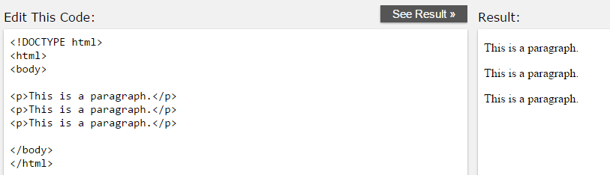

## The HTML <pre> Element

Example

<pre>  
  My Bonnie lies over the ocean.  
  
  My Bonnie lies over the sea.  
  
  My Bonnie lies over the ocean.  
  
  Oh, bring back my Bonnie to me.  
</pre>

